**Devops Application Deployment ( Capestone Project)**

**Git hub repo URL:** <https://github.com/deepakramamoorthy/DevOps-Application-Deployment.git>

**Deployed site :** I can’t run the EC2 Machine till your grading, i have attached the screenshot of the deployed site below.

**Docker Images name:** reactapplicationdev , reactapplicationprod

**Screenshots:**

**AWS :**

* Aws EC2 Console ( Ubuntu machine)

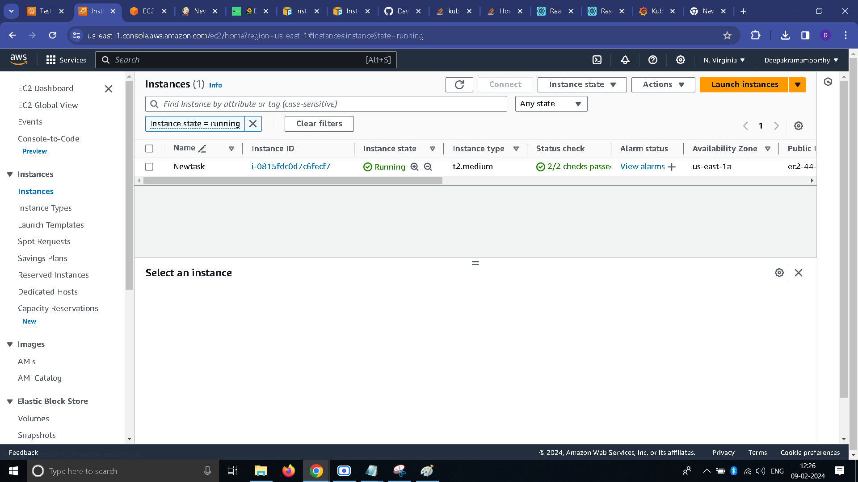

* AWS EC2 Console ( Node)

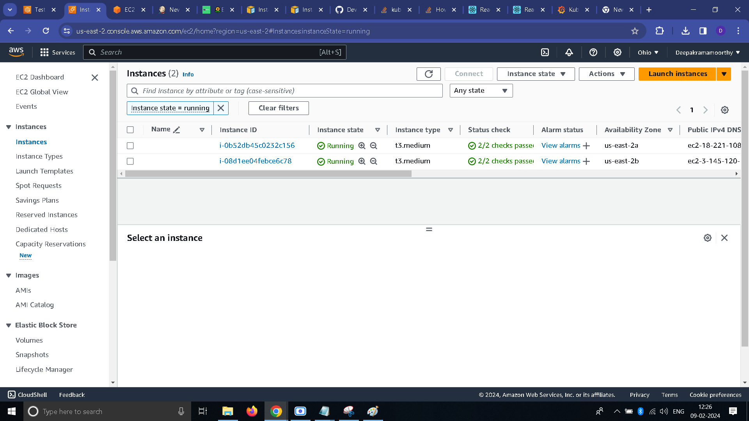

* Security group configuration ( Ubuntu machine)

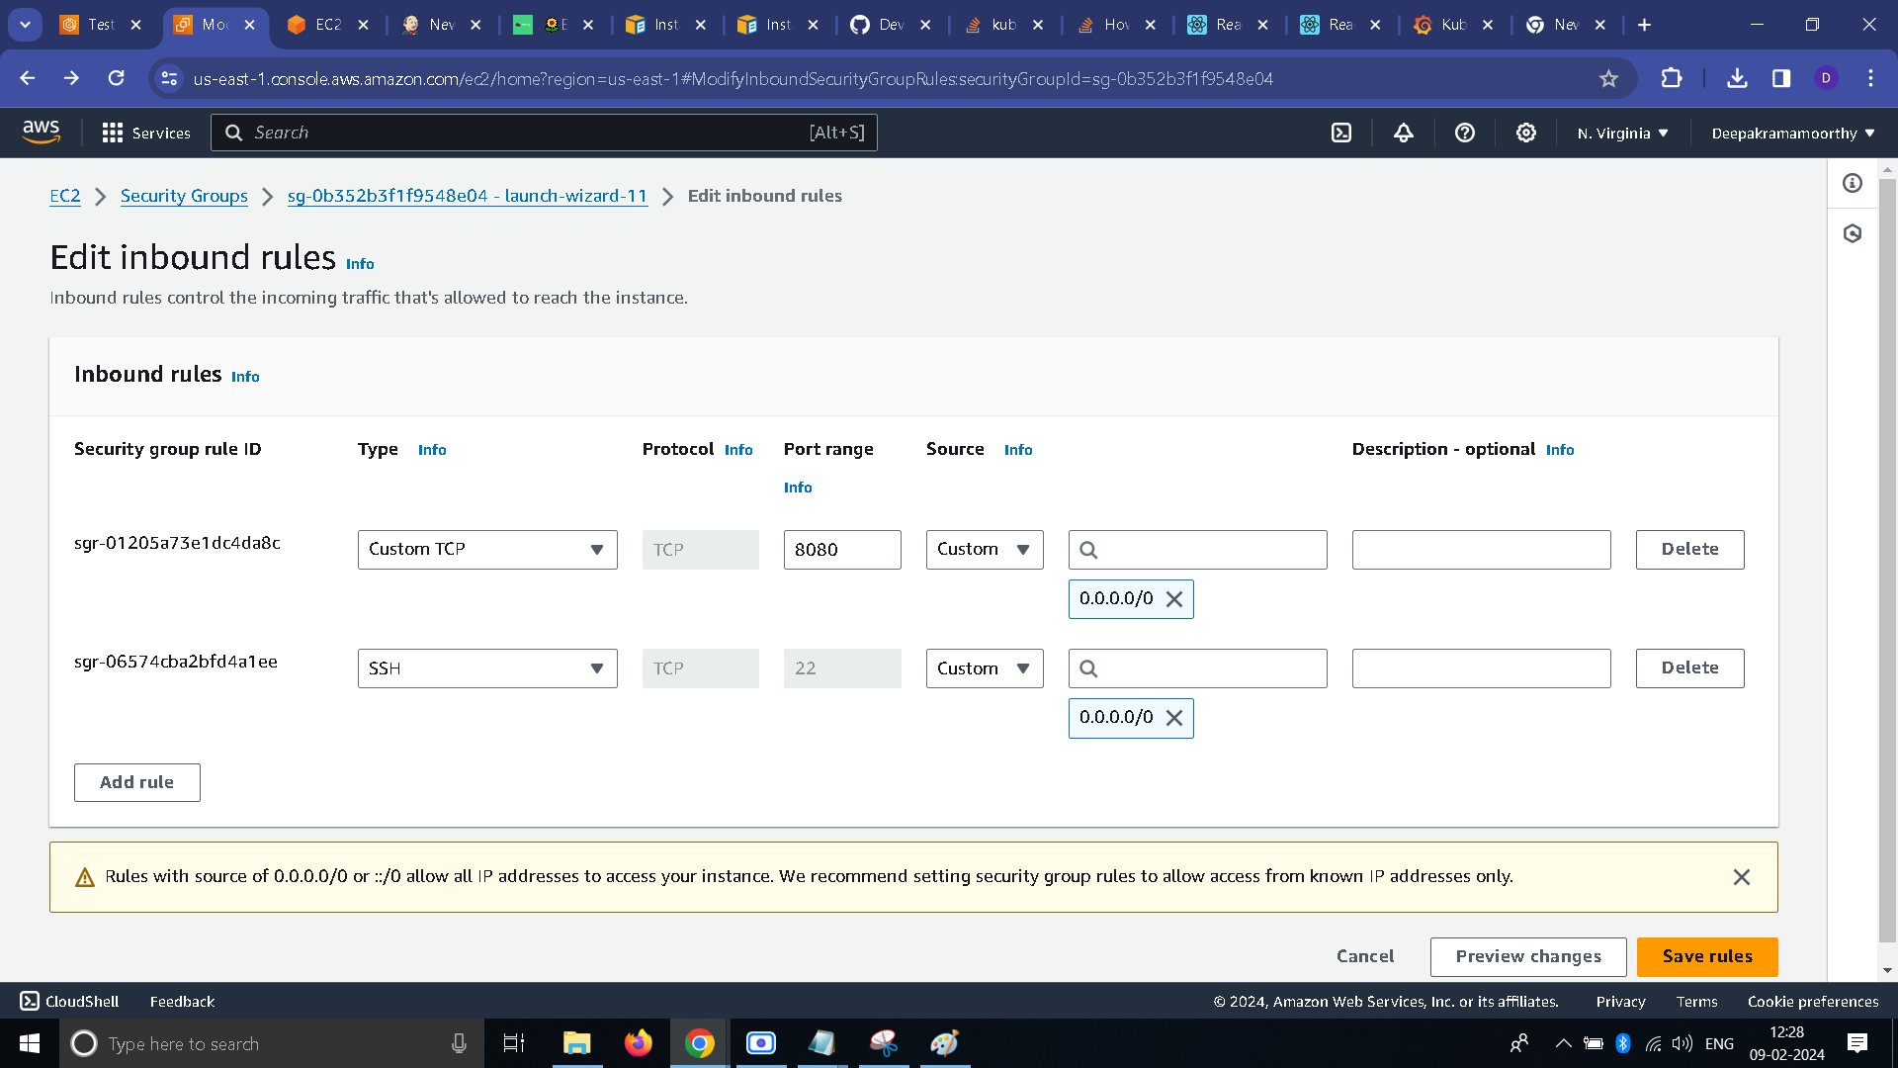

* Security group configuration ( Node)

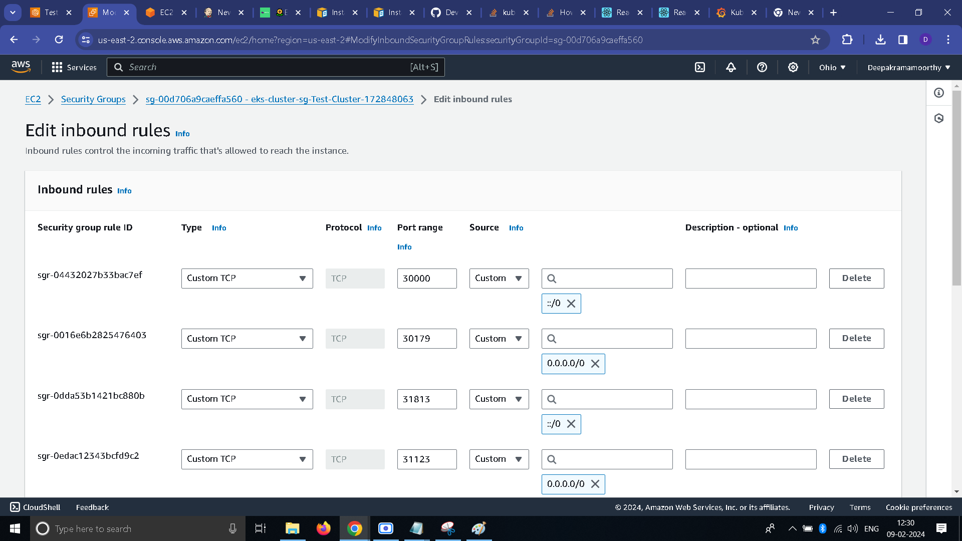

**Docker Hub:**

* Docker Hub repo with image tags

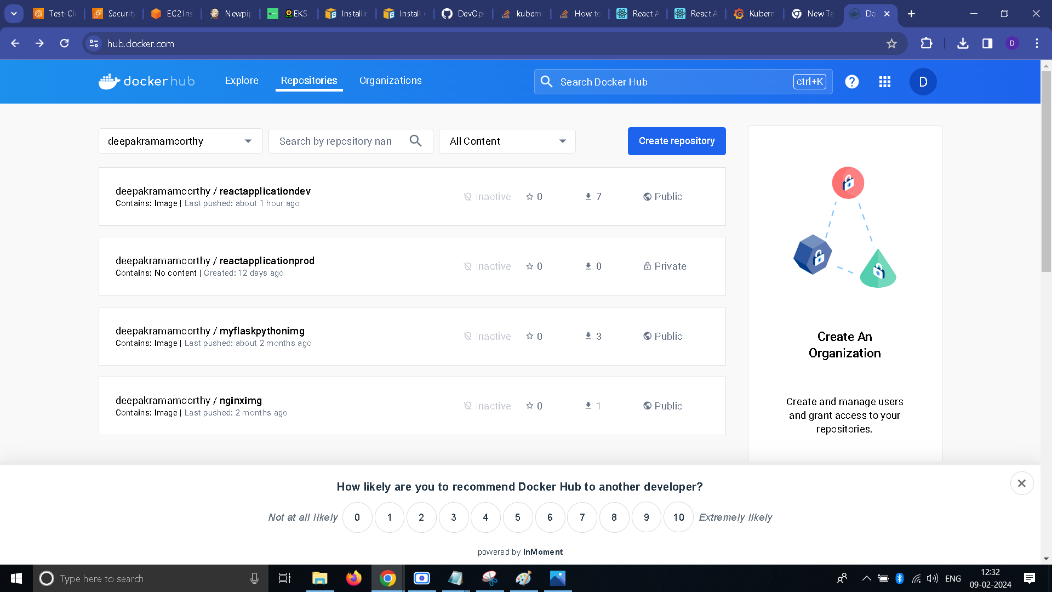

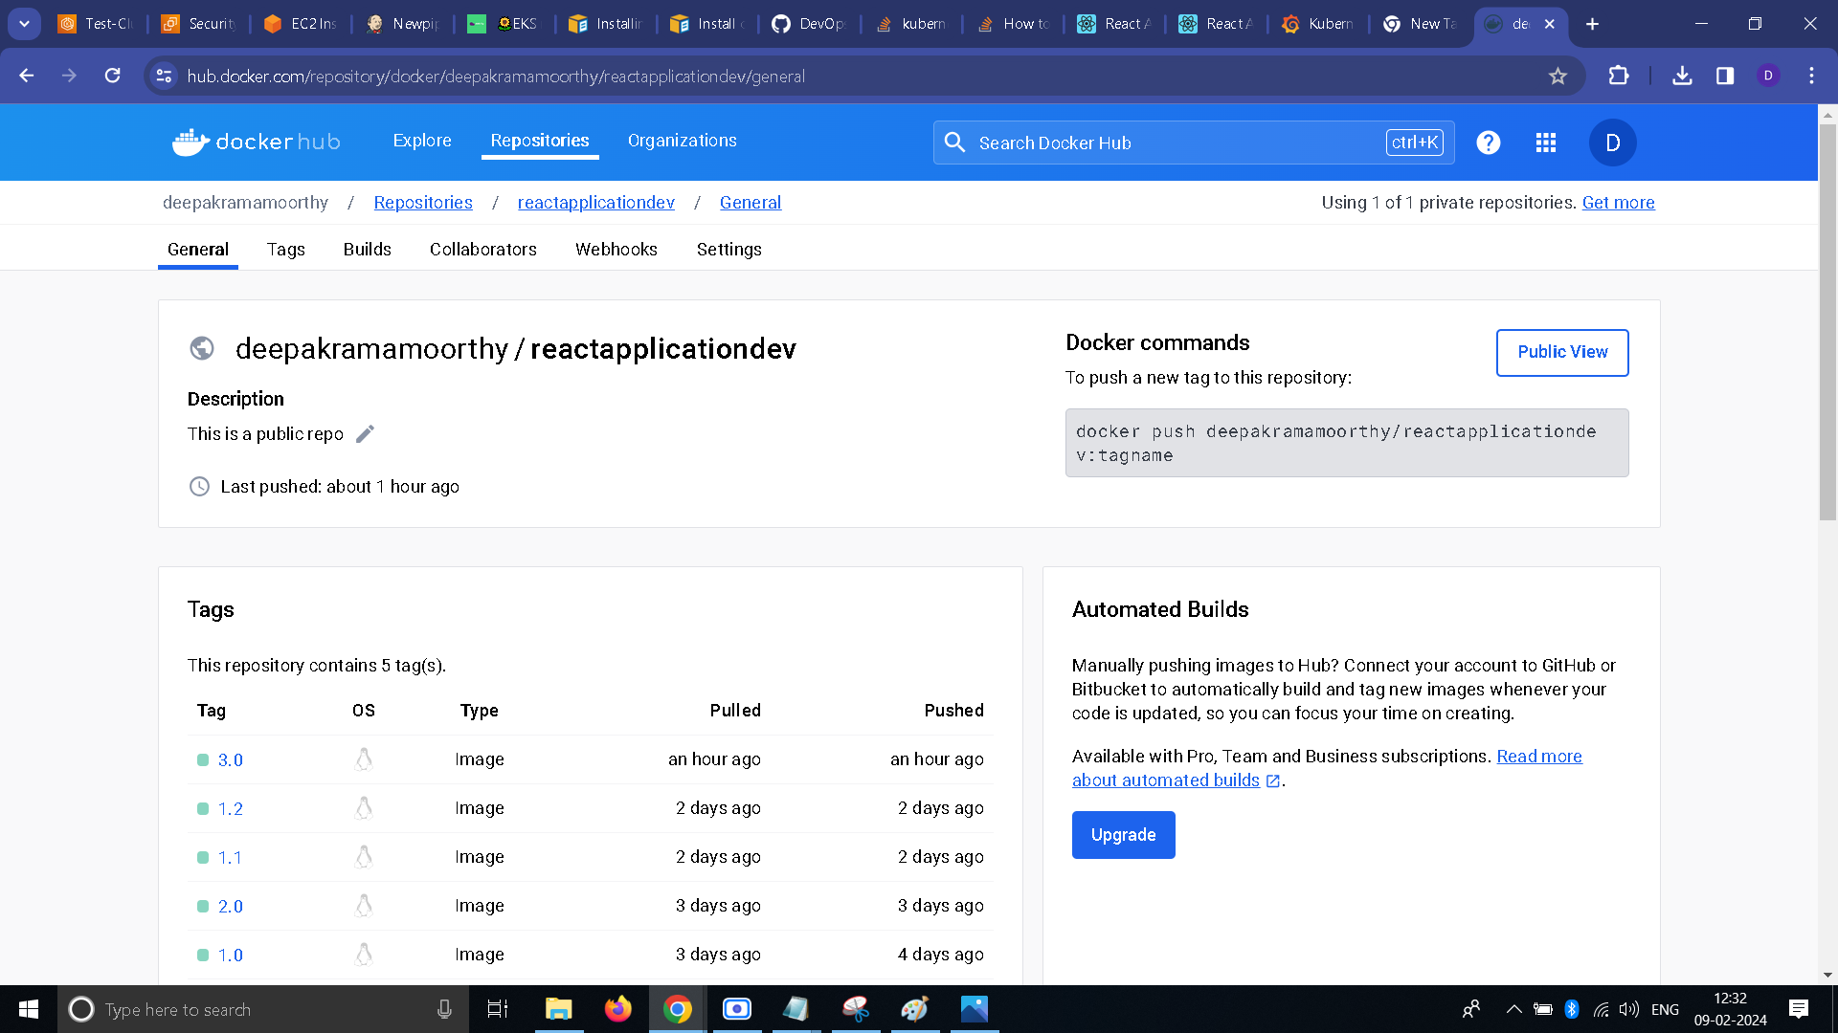

**Jenkins:**

* Jenkins Login page

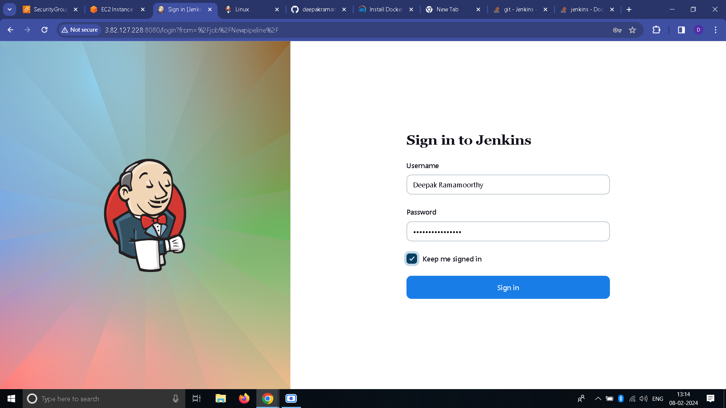

* Configuration settings

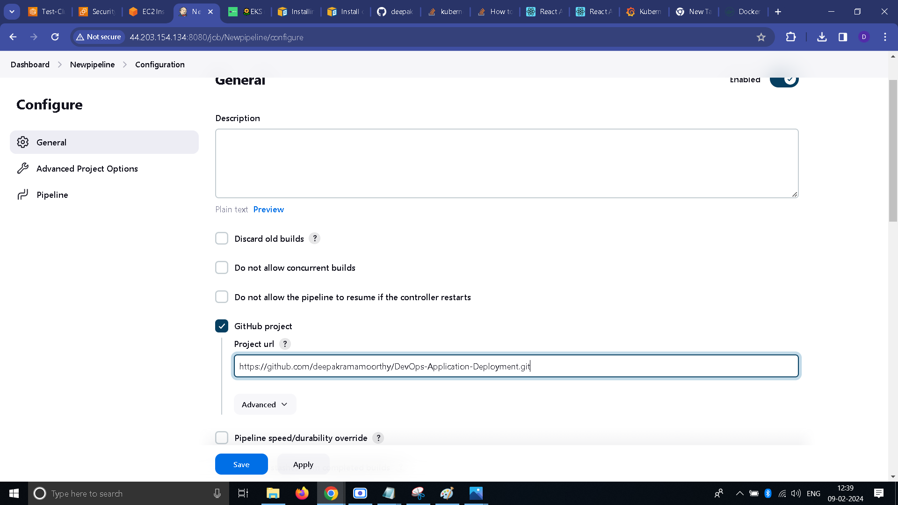

* Execute step commands ( Please find the commands in git hub repo, **file name : jenkinsfile**)

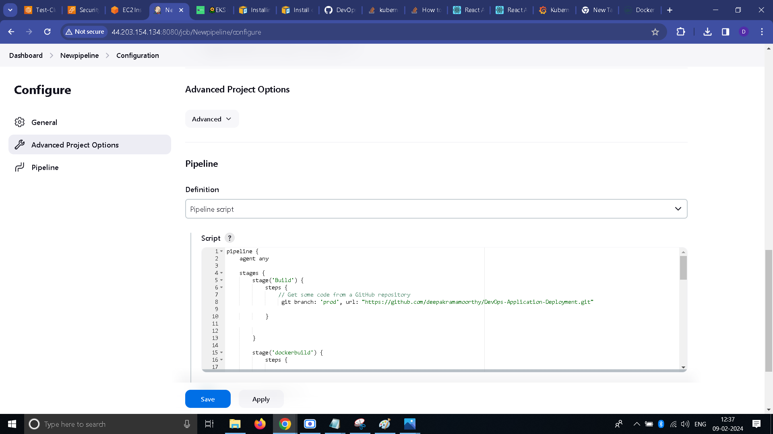

* Console output

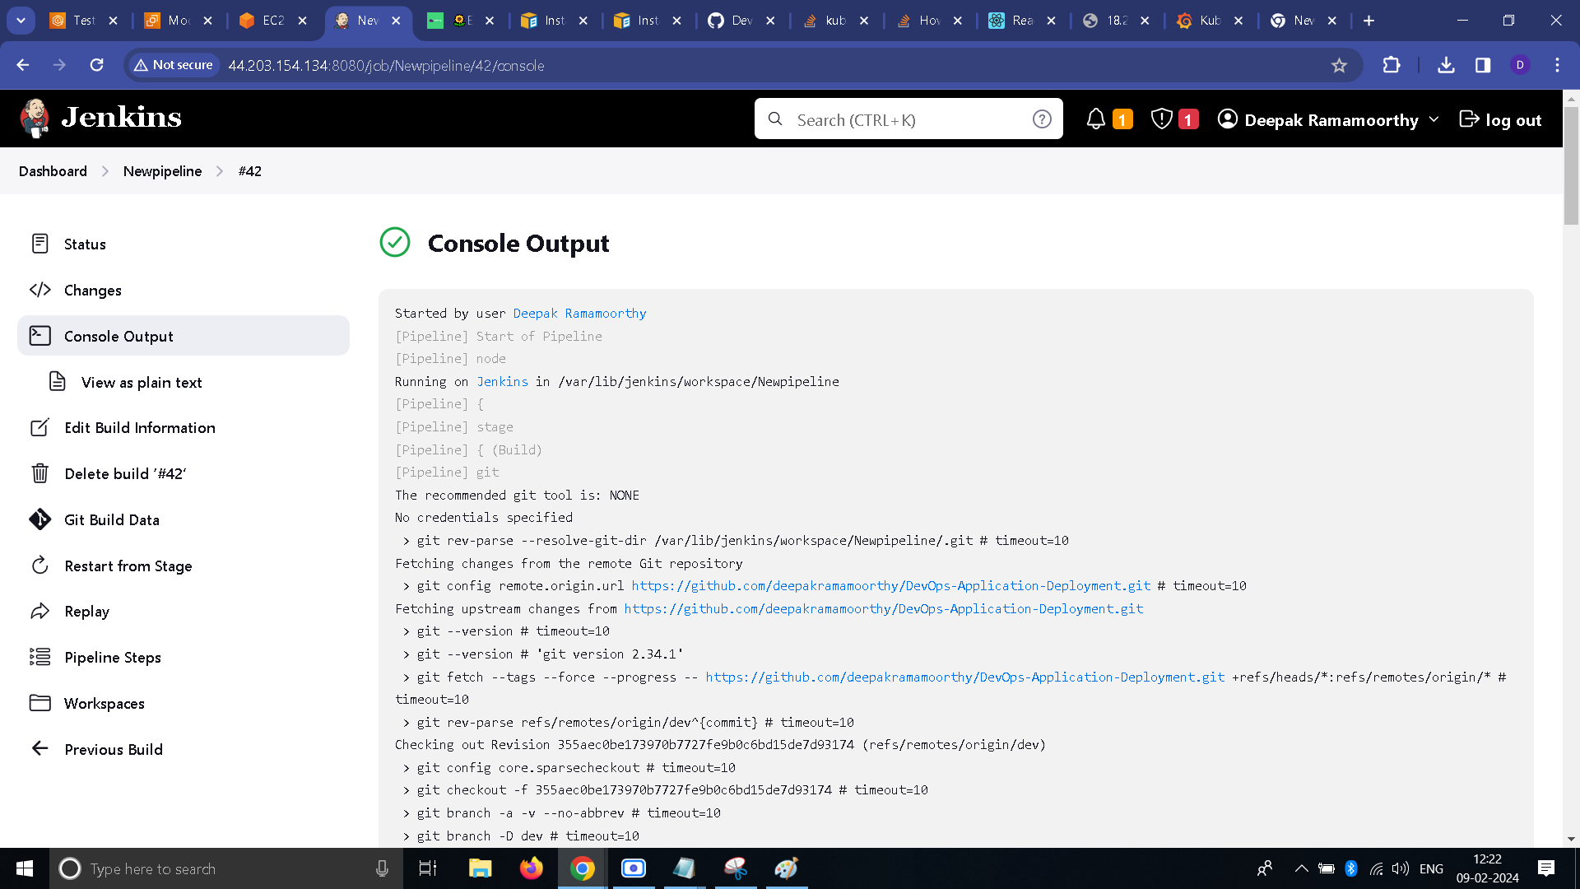

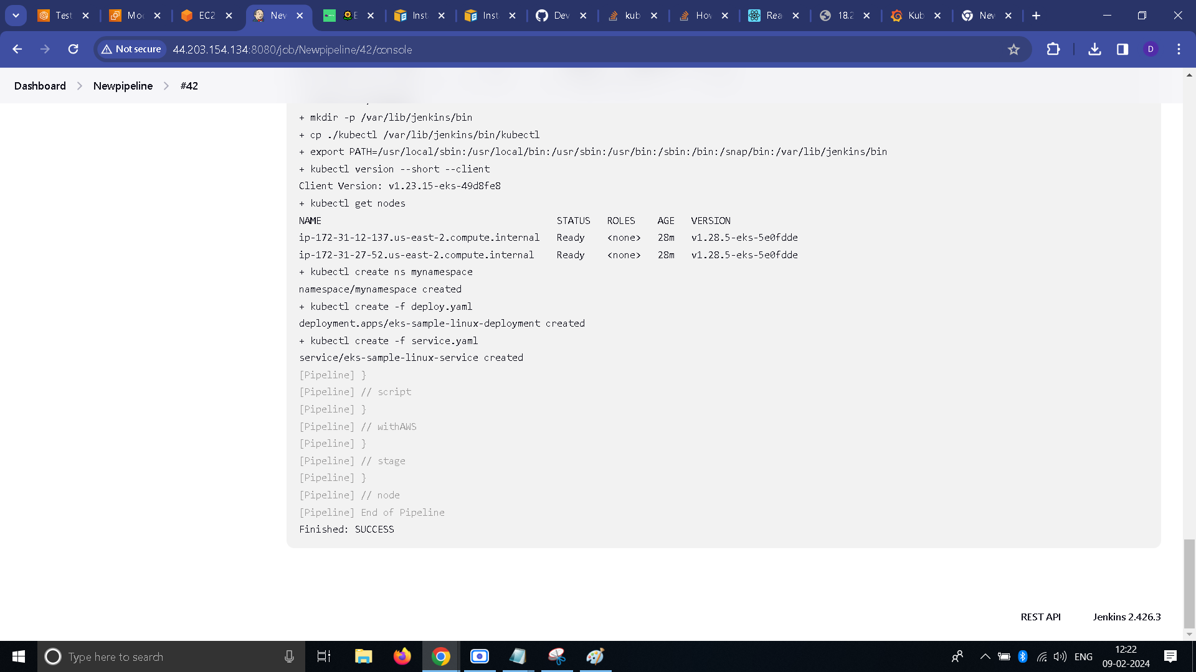

**EKS:**

* EKS Cluster

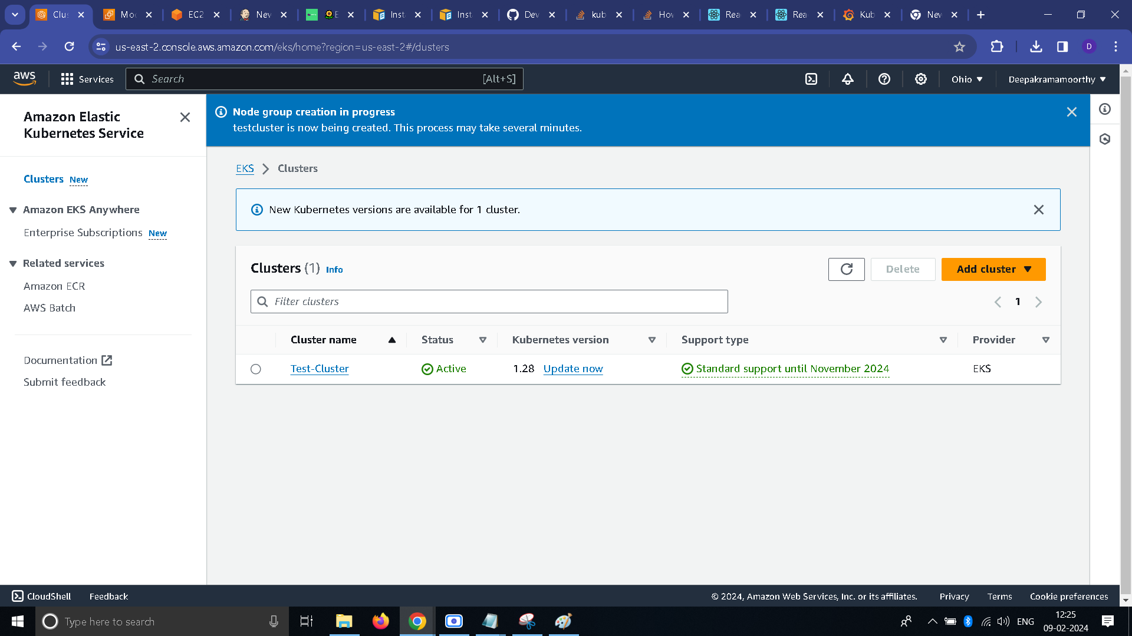

* Node Group

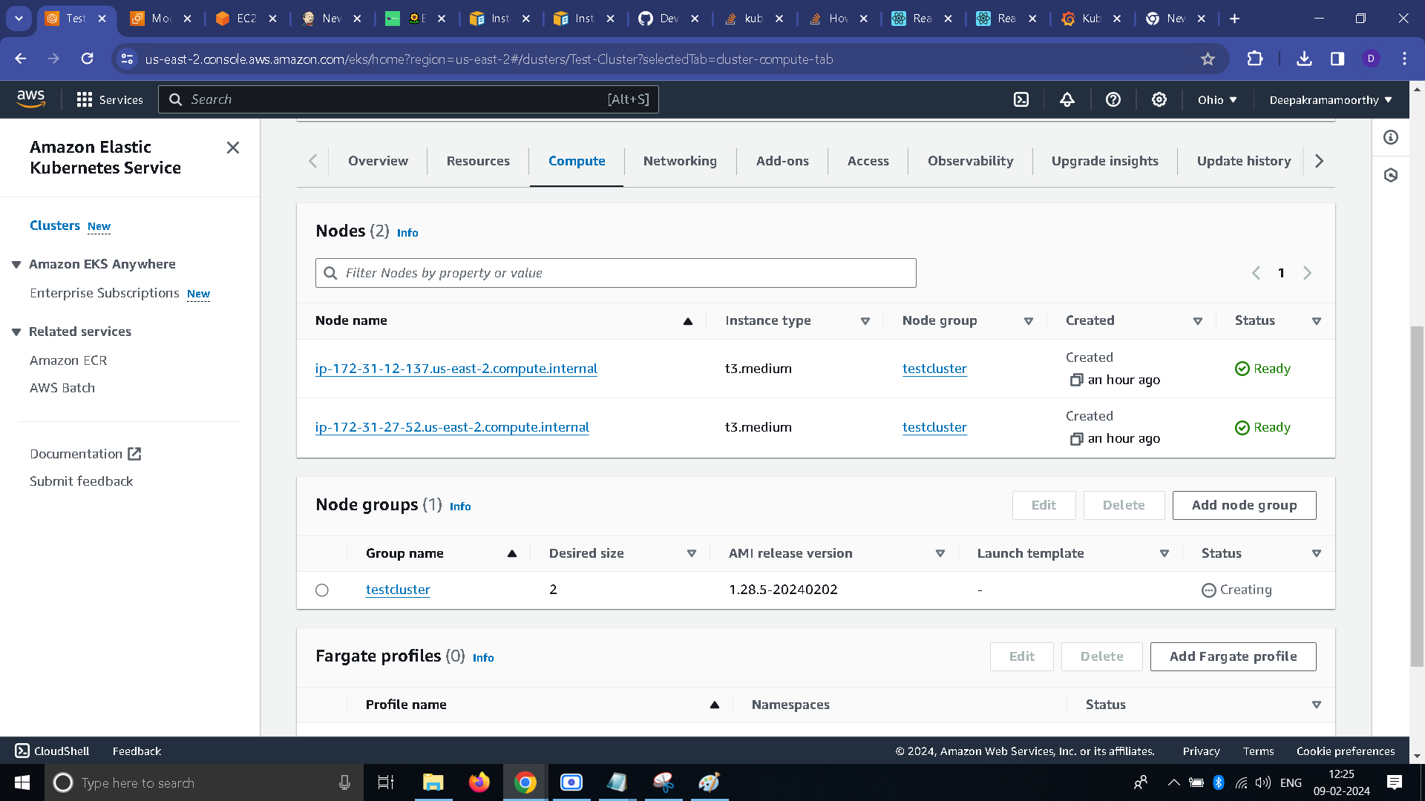

* Kubernetes services.

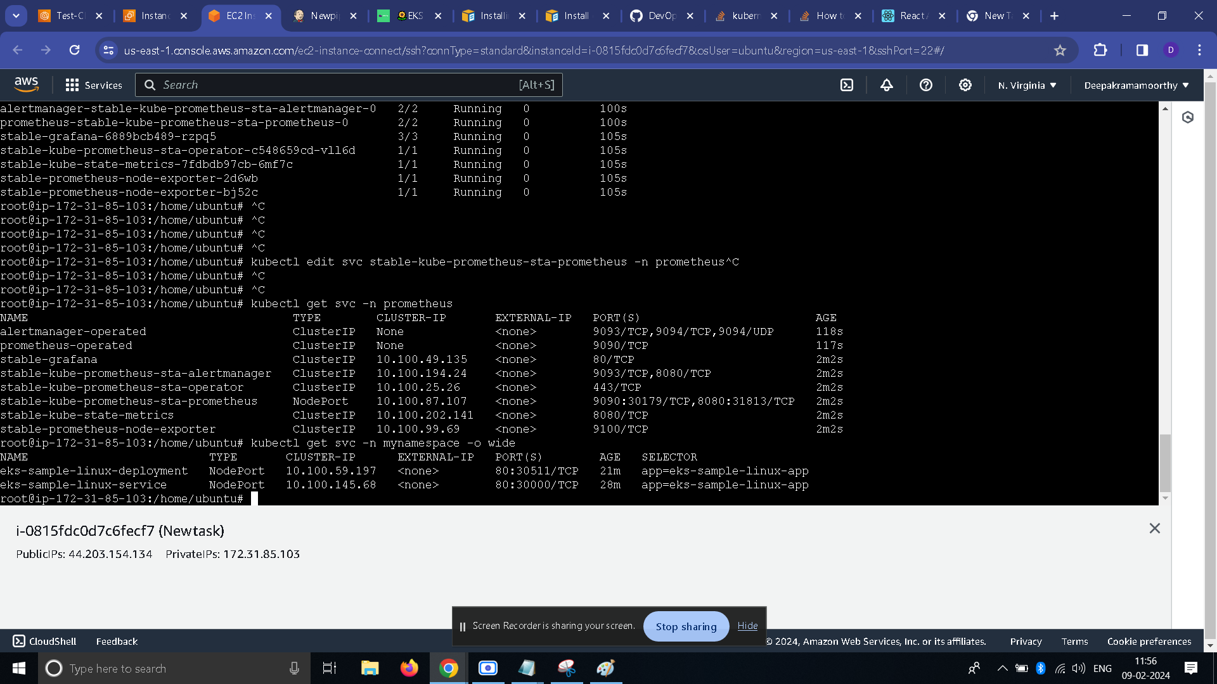

**Deployed Site Page:**

* I have **exposed** the given application using **Node port and Node IP.**

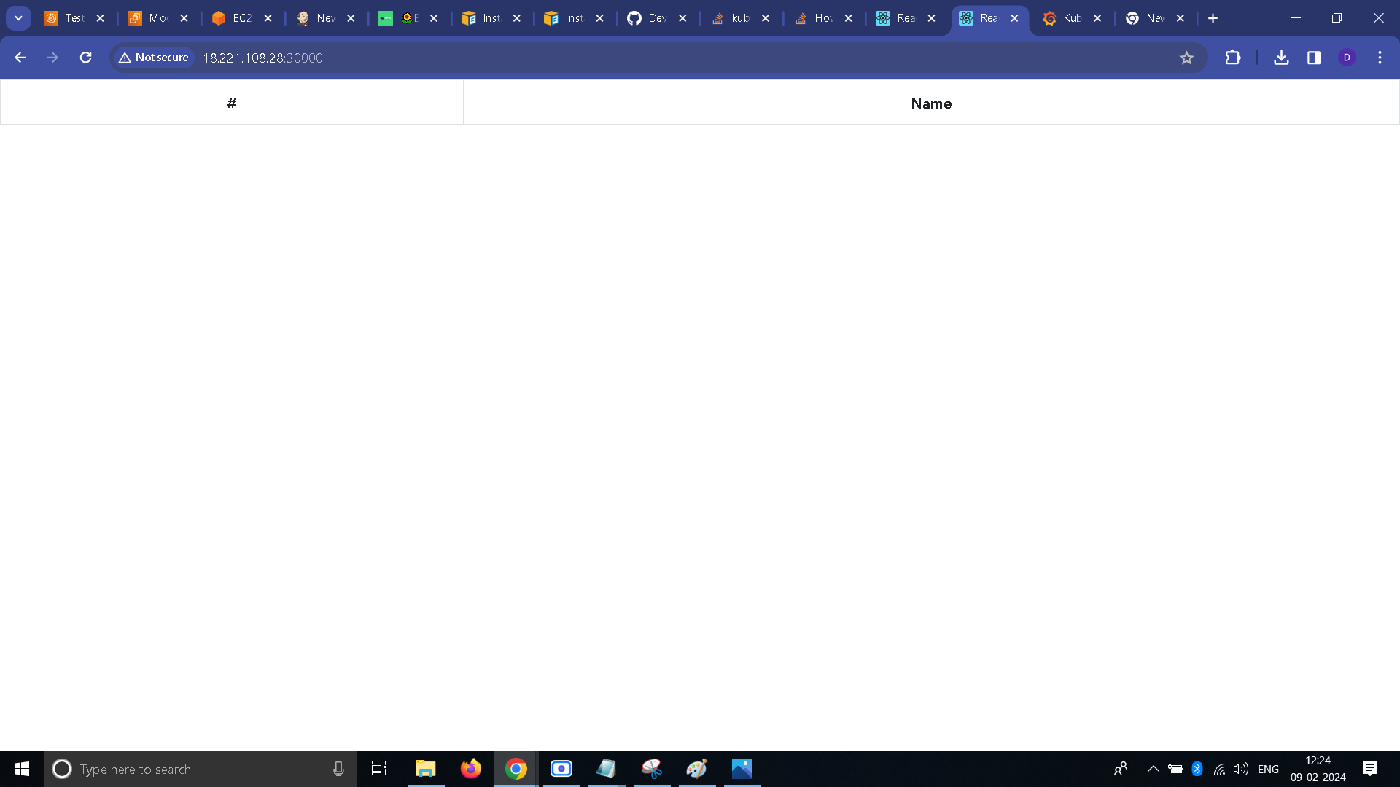

**Monitoring Tool:**

* Prometheus

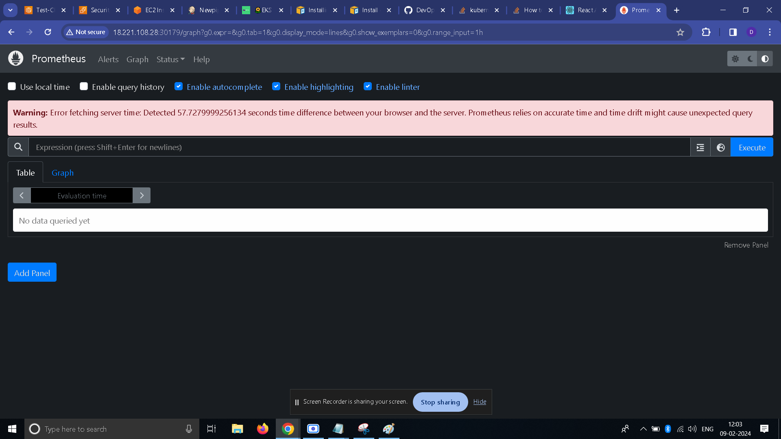

* Grafana

